“Formando hombres y mujeres: dueños de su propio destino”
Name: ____________________________
Grade: _____________

English Worksheet: Personal Pronouns

OBJETIVES  * Identify use of Personal Pronouns  * Apply simple vocabulary related with the Unit | ITEMS  * Choose the correct P. Pronoun and translate terms  * Change sentences  * Complete a text

INSTRUCTIONS:

- Lea atentamente las indicaciones y enunciados antes de contestar.
- Guía de carácter INDIVIDUAL
.

- Choose the correct personal pronouns, and in your notebook translate the nouns below:
A girl

A book

Kids

A boy

Players

Gloves
A boy

A dog

A rose

A ball

A farmer
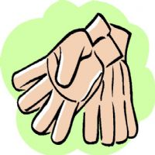
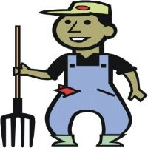

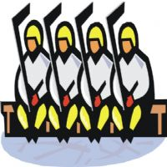
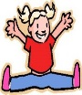

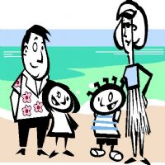
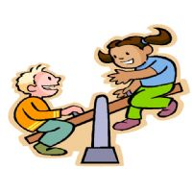

A family

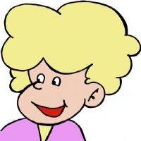

- Change these sentences:

- For example: My father is tall He is tall.

This ball is small. ……… is small.
This rose is red. ……… is red.
My father is a farmer. ……… is a farmer.
My mother is thirty. ……… is thirty
Boby is my dog. ……… is my dog.

- Choose the pronoun(s) that completes each sentence correctly.

1. This queen is wearing a beautiful cape. _____ is pink and elegant. (her, it)
2. Bob and Julia work in a hospital. _______ work for long hours. (she, she, they)
3. Pizza is the Brown’s favorite food. Pam bakes _____ for _____ family every Friday. (her, his, it)
4. Pedro’s favorite subject is Science. ______ has a tremendous bug collection. (their, he)
5. Rover loves playing with _____ rubber bone. However, ________ can’t find _______ anywhere. (it, he, his, their)
6. Cindy is a friendly person who waves at _____ neighbors when _______ pass by. (them, they, her)
7. CeCe loves lying on ______ bedroom floor. ________ thinks off everything that happened during the day. (his, her, she)
8. George and his band practice at ______ house on Friday’s. _______ play at the local pizzeria. (his, him, they)
9. These kids love ______ country. _____ are wearing ______ national colours. (them, they, their, he)

